

INDIVIDUAL ASSIGNMENT

COMP40004

**WEB DEVELOPMENT AND OPERATING SYSTEMS-1**

**CFK23A1COM**

HAND OUT DATE: 3nd week

HAND IN DATE: ASSIGNMENT2: 19th Jan 2024

WEIGHTAGE: ASSIGNMENT 2: 30%

**INSTRUCTION TO CANDIDATES:**

1. **Students are advised to underpin their answers with the use of references (cited using the Harvard Name System of Referencing).**
2. **Late submission will be awarded zero (0) unless Extenuating Circumstances (EC) are upheld.**
3. **Cases of plagiarism will be penalized**
4. **Assignment presentation should be submitted in the form of softcopy and hardcopy both; modeling work should be submitted in softcopy form**

# **Acknowledgement**

I would like to thanks Mr. Pradeep Pallegama for guiding us throughout this module, Web Development and Operating Systems. Also, I would like to sincerely thank my colleagues who helped me out throughout the assignment. And finally, I would like to thank every individual who supported me to overcome this assignment and make it a success.

**Table of Content**

**Acknowledgement** 1

**Introduction** 4

**Website** 4

**Project Learnings** 5

**Challenges Faced and Solutions Implemented** 7

**Conclusion** 12

# **Introduction**

The process of creating a website is documented in this project brief, focusing on the valuable lessons learned and the challenges that come with it. As first-year undergraduates, this project provided a thrilling opportunity to delve into the world of web development, pushing our boundaries and expanding our skillsets.

## **Website**

This website is about Sri Lankan Wildlife and was prepared according to the specification given in the brief. The website mainly consists of seven pages Homepage, Introduction, About Us, Sri Lankan Leopard, Animals in Sri Lanka, Wilpattu National Park, Yala National Park and three extra webpages which are Kumana National Park, Events page and the Contact page. A more detailed overview of the website can be found in Website Structure Overview.

This website can be visited at: <https://deathflesh.github.io/Wildlife.lk/>

# **Project Learnings**

1. **Target Audience-Centric Design:** Understanding and preparing the website to the needs and preferences of the target audience and designing the website according to the given specifications significantly influenced the design and functionality of the web application which helped me to learn how to prepare a good website according to the users need as well as in a technically good manner.

2. **Mobile responsiveness:** By engaging in this assignment, I got the basic idea how to make a website responsive across devices as well as I learned more advanced techniques to make a webpage highly responsive and mobile friendly.

3. **Adherence to Current Web Standards:** Following and implementing the latest web standards, including HTML5, CSS3, which ensured the compatibility towards devices, security, and enhanced performance. And also going through the W3C standards gave me an idea how to maintain good color contrast between text and other content of the website. Which then I choose to use the below mentioned color pallet with a little touch of blur effect

|  |
| --- |
| #555f0b |
| #bacf16 |
| #ffffff |
| #021116 |
| #262626 |

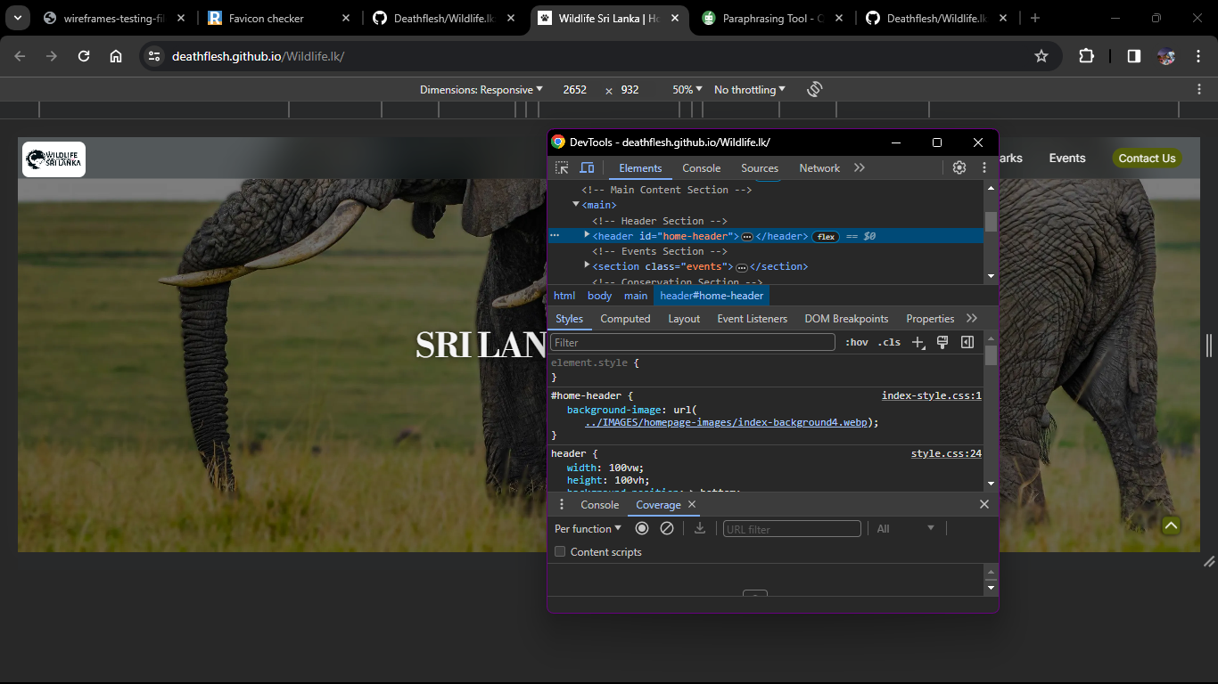4. **Testing across devices:** Testing the website across devices was a major concern order to get a good responsiveness. For testing purposes, I used the google chromes built in DevTools function and its useful dimensions prepared accordingly for various device models, which also gave me the basic knowledge how to use it to find error in my code as well.

# **Challenges Faced and Solutions Implemented**

1. **Workspace Neatness:**
   * **Challenge:** maintaining the cleanliness and organization of the workspace.
   * **Solution:** As a solution and in order to maintain workflow and neatness as well as boost productivity, I used the Visual Studio Codes features, such as creating a default work space in the Explorer, which also saved me time opening folders every time I start to work.

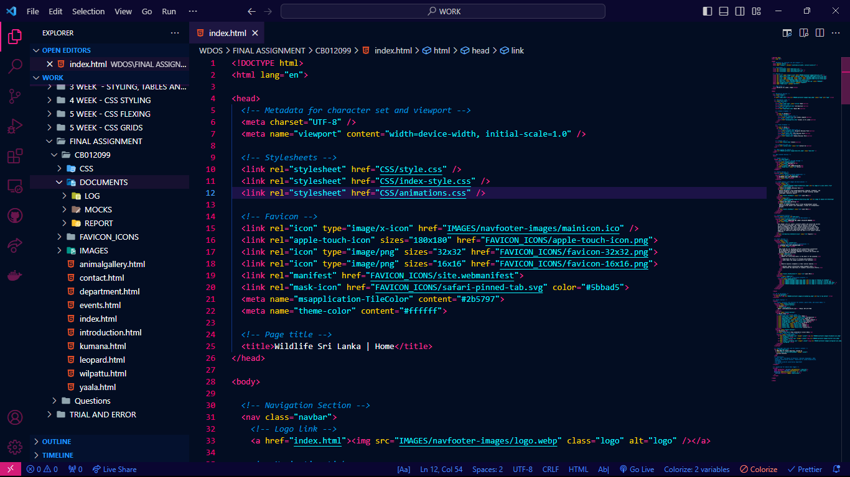

Workspace is categorized into folders

Comments are used to identify the codes easily

1. **Code Segregation:**
   * **Challenge:** Separating common stylings and unique stylings for specific webpages.
   * **Solution:** At first, I started this project by only using one external CSS file, which became a mess. So, in the middle of the project, it was a bit challenging to identify the common styles and the unique styles for specific webpages as there were thousands of codes, but after analyzing the code carefully using the Google DevTools coverage to identify which codes are unique and common for the pages, I was able to overcome this challenge by separating the codes to their respective CSS files, and it also helped me to solve some responsiveness errors that happened due to CSS class collisions.

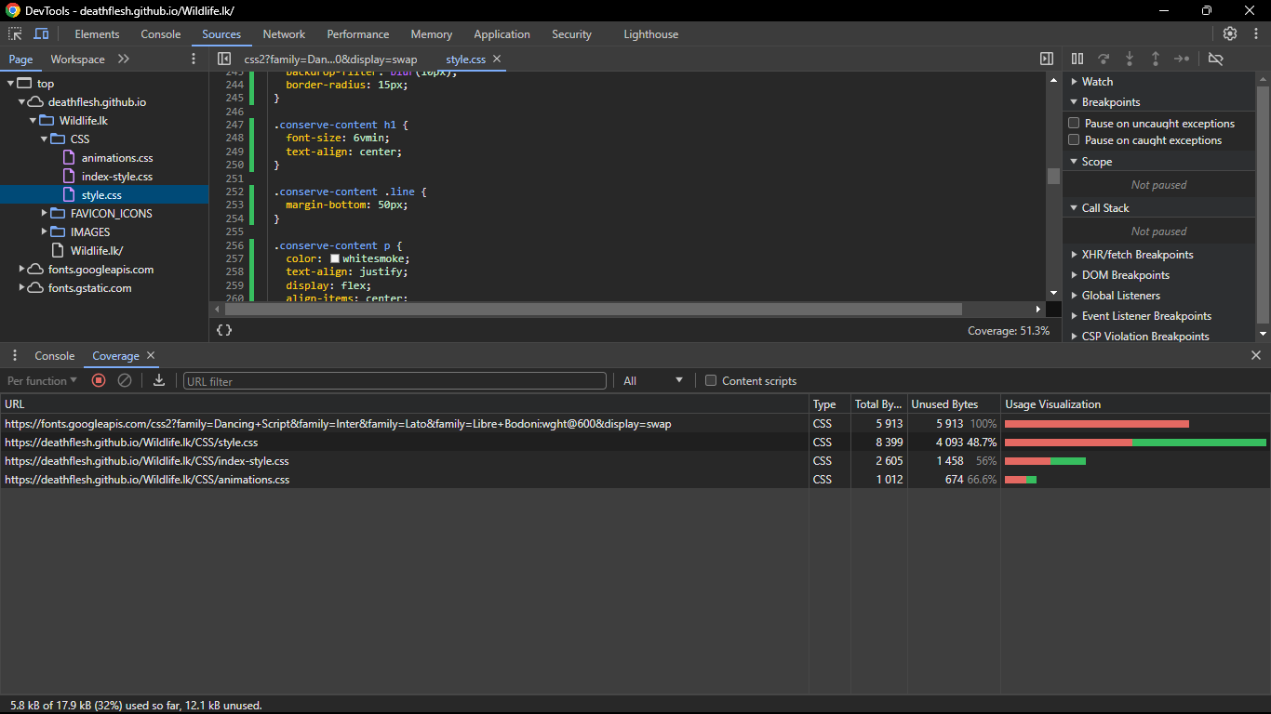

1. **Responsive Web Design:**
   * **Challenge:** ensuring responsiveness across various devices and resolutions.
   * 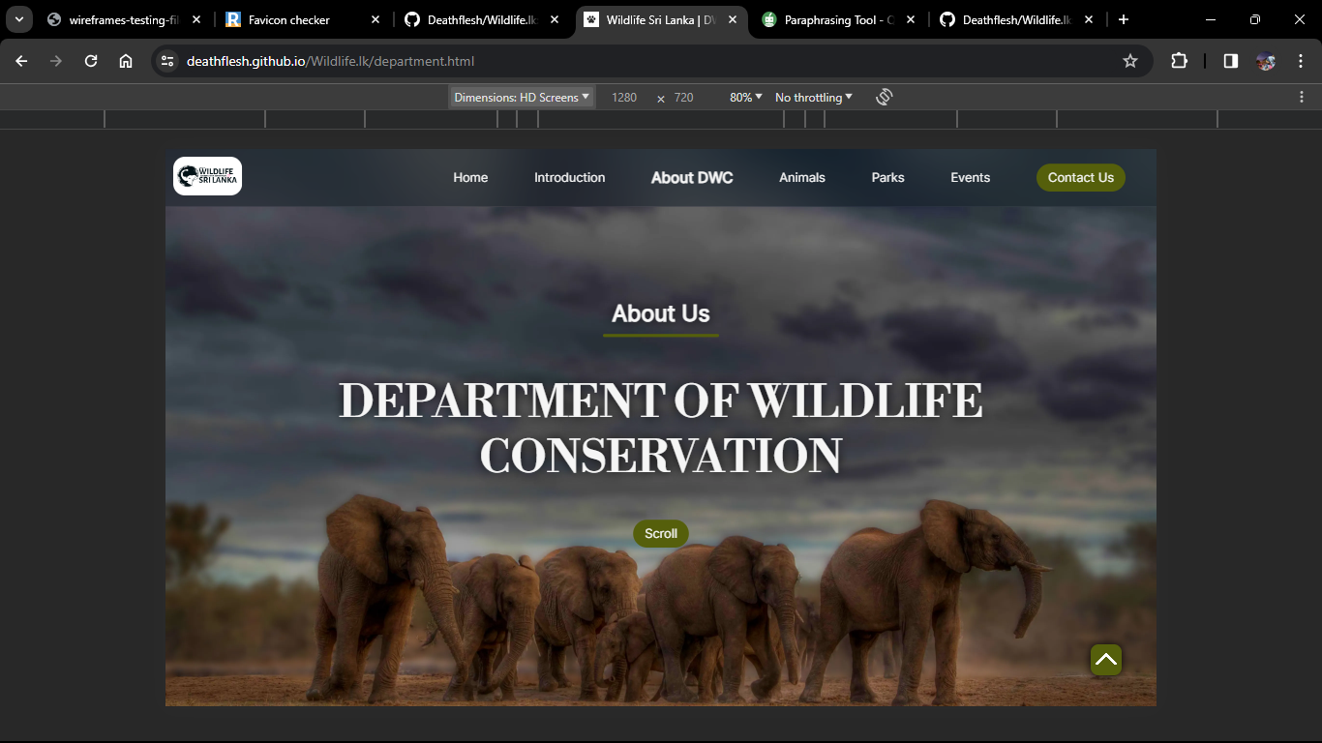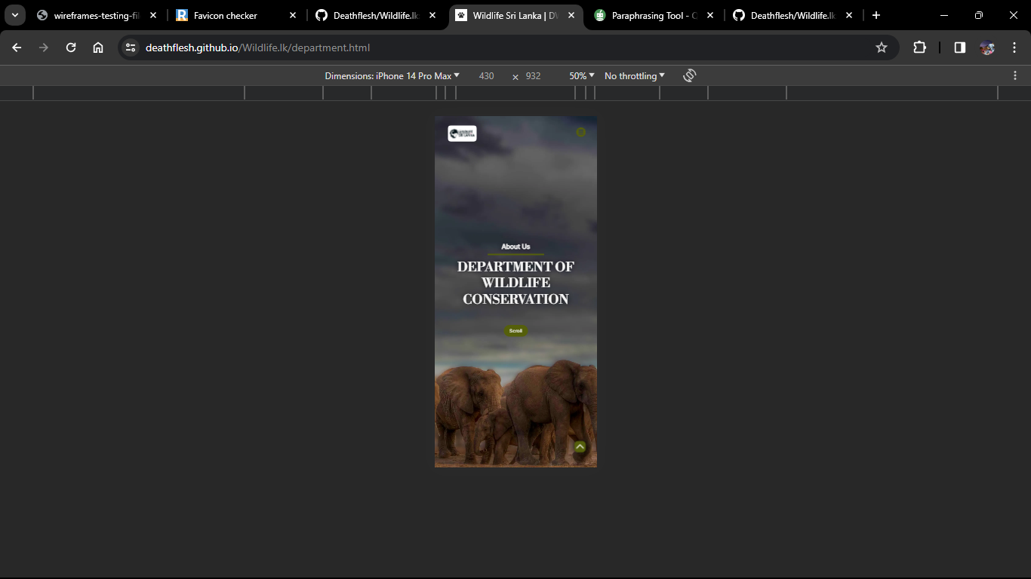**Solution:** It was bit challenging to make my website responsive to small devices such as mobile phones so as a solution I used media queries and flex boxes to make the webpages highly responsive for all screen sizes.
2. **Using Grids to prepare the layout:**
   * **Challenge:** It was hard to identify grids in the layout
   * 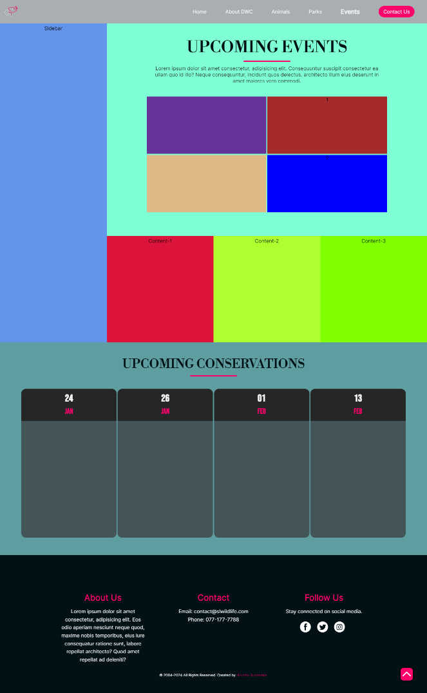**Solution:** So, as a solution I used different colors to represent each grid while creating the layout. This helped me to get a good understanding of the code and what section I was editing on.

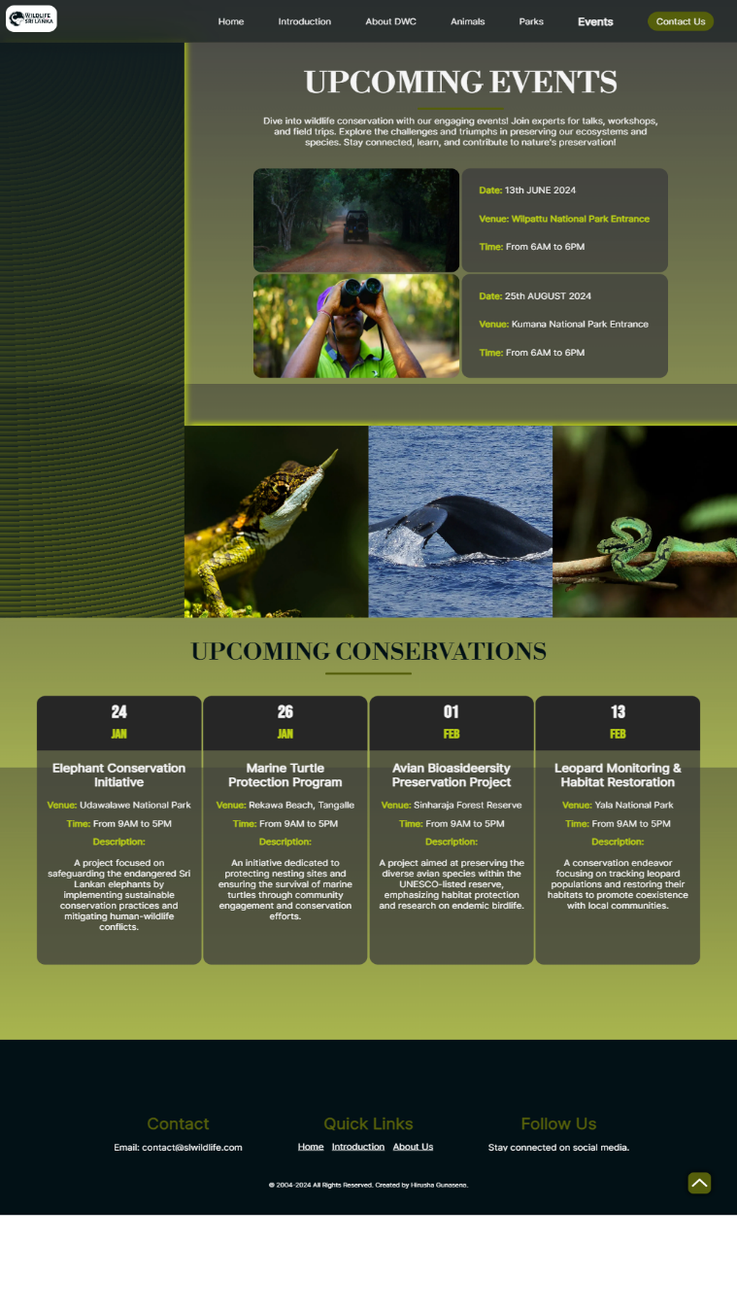

1. **Uploading the files in the GitHub:**
   * **Challenge:** To make the website work correctly after hosting
   * **Solution:** At first when I uploaded the CSS, HTML and Image folders that contain my codes it was not working so after trying several fixes I noted that the HTML files need to be in the root with the homepage specially named as index.html.
2. **Fine tuning the website:**
   * **Challenge:** Higher loading times when hosted
   * **Solution:** When the website is hosted it took a long time to load especially the images, and this will be a major problem when consider the user experience. With the help of the DevTools I was able to identify the errors and I converted the large image formats such as png and jpeg to webp which is a highly compressed image format which gave me a good website performance.

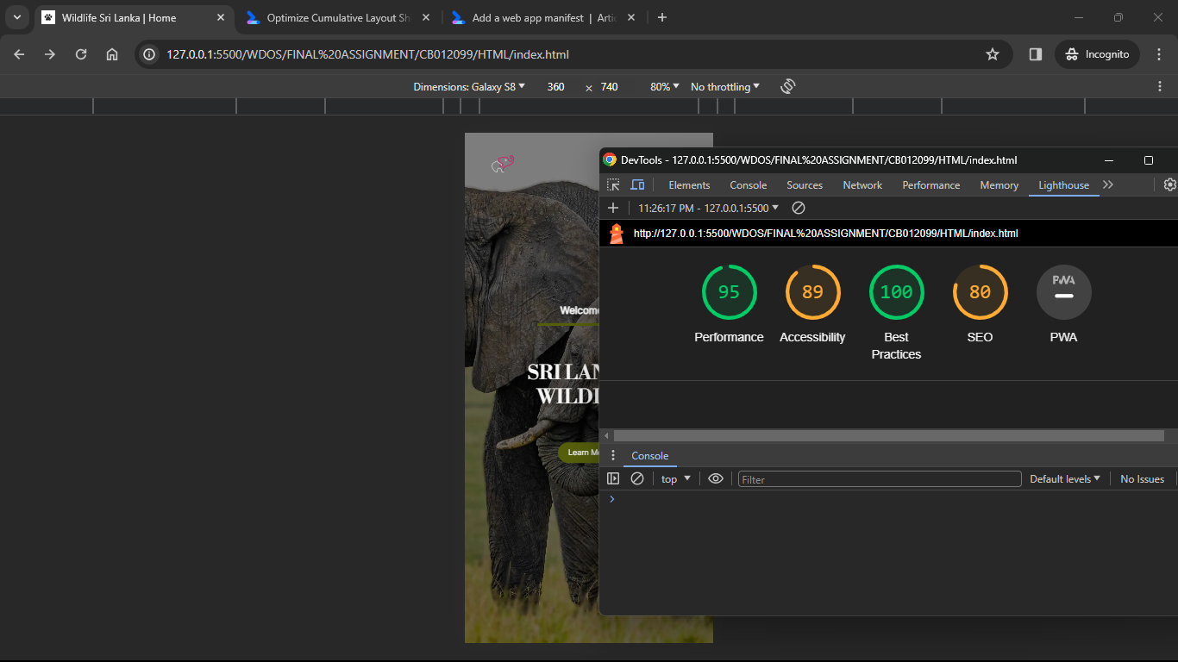

# **Conclusion**

Building this Sri Lankan Wildlife website was more than just an assignment but it was a transformative learning experience. It was covering a vast number of areas such as good coding practices and it helped me to figure out what are the things that I am good at and also my weak areas. It was a bit hard to overcome the given specification in the first attempt but after several tries the codes and the techniques became familiar with me which helped me to make this a success.